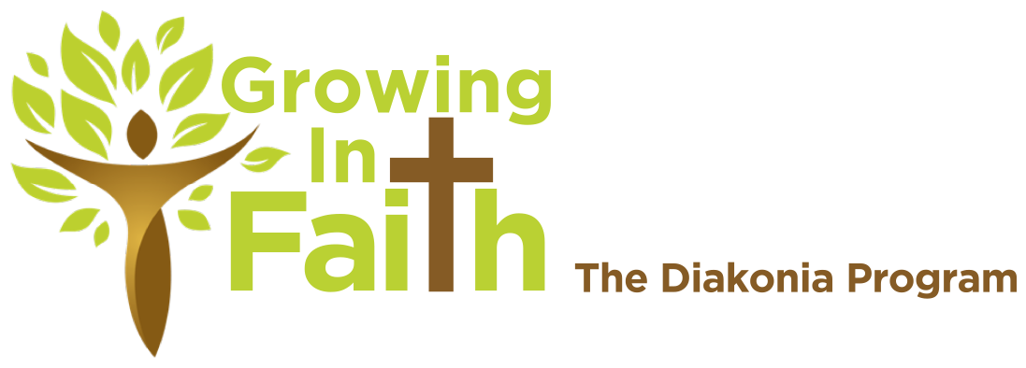

Longing to Grow? Plant yourself in good soil.
Growing in Faith is a ministry committed to fostering learning environments for followers of Jesus to grow in faith. This program gathers lay members across parishes to encourage healthy discipleship in churches and communities.

How It Works
Participants gather in-person or over zoom for six 5-week classes. Each class is 3 hours long and involves a combination of instruction, discussion, and experiential learning.

Begin with our Foundations Year, then decide if you would like to stretch yourself through a Practical Year. Each course is $65. Courses may be taken individually. Financial assistance is available upon request.

NWOS 2022-2023 Schedule
Thursdays from 6 – 9 p.m.
In-person at Trinity, Findlay or online through Zoom

Worship Matters: Sept. 22, 29, Oct. 6, 13, 20
Christianity in a Lutheran Key: Nov. 3, 10, 17, Dec. 1, 8
Intro to Old Testament: Dec. 22, Jan. 5, 12, 19, 26
Intro to New Testament: Feb. 9, 16, 23, Mar. 2, 9
Lutheran Creeds and Confession: Mar. 23, 30, Apr. 13, 20, 27
Living as Christians in the World: May 11, 18, 25, Jun. 1, 8

Explore more at www.nwosdiakonia.org

Longing to Grow? Plant yourself in good soil.
Growing in Faith is a ministry committed to fostering learning environments for followers of Jesus to grow in faith. This program gathers lay members across parishes to encourage healthy discipleship in churches and communities.

How It Works
Participants gather in-person or over zoom for six 5-week classes. Each class is 3 hours long and involves a combination of instruction, discussion, and experiential learning.

Begin with our Foundations Year, then decide if you would like to stretch yourself through a Practical Year. Each course is $65. Courses may be taken individually. Financial assistance is available upon request.

NWOS 2022-2023 Schedule
Thursdays from 6 – 9 p.m.
In-person at Trinity, Findlay or online through Zoom

Worship Matters: Sept. 22, 29, Oct. 6, 13, 20
Christianity in a Lutheran Key: Nov. 3, 10, 17, Dec. 1, 8
Intro to Old Testament: Dec. 22, Jan. 5, 12, 19, 26
Intro to New Testament: Feb. 9, 16, 23, Mar. 2, 9
Lutheran Creeds and Confession: Mar. 23, 30, Apr. 13, 20, 27
Living as Christians in the World: May 11, 18, 25, Jun. 1, 8

Explore more at www.nwosdiakonia.org

